Exp(11-15)
Name:LAKSHMI REDDY Y
Reg.No:192324077
Exp-11
from sklearn.datasets import load_breast_cancer
from sklearn.model_selection import train_test_split
from sklearn.linear_model import LogisticRegression
from sklearn.metrics import accuracy_score, confusion_matrix, classification_report
data = load_breast_cancer()
X = data.data
y = data.target
X_train, X_test, y_train, y_test = train_test_split(X, y, test_size=0.3, random_state=42)
model = LogisticRegression(max_iter=10000)
model.fit(X_train, y_train)
y_pred = model.predict(X_test)
acc = accuracy_score(y_test, y_pred)
cm = confusion_matrix(y_test, y_pred)
cr = classification_report(y_test, y_pred)
print("Accuracy:", acc)
print("Confusion Matrix:\n", cm)
print("Classification Report:\n", cr)
output:
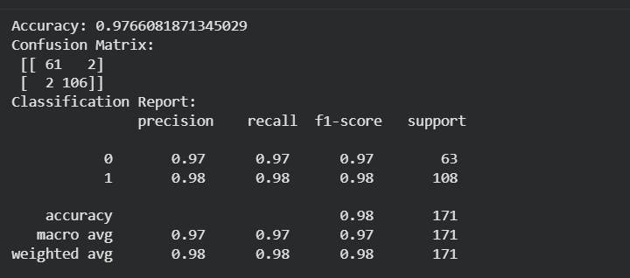
Exp-12
from sklearn.datasets import load_breast_cancer
from sklearn.model_selection import train_test_split
from sklearn.ensemble import RandomForestClassifier
from sklearn.metrics import accuracy_score, confusion_matrix, classification_report
data = load_breast_cancer()
X = data.data
y = data.target
X_train, X_test, y_train, y_test = train_test_split(X, y, test_size=0.3, random_state=42)
model = RandomForestClassifier(n_estimators=100, random_state=42)
model.fit(X_train, y_train)
y_pred = model.predict(X_test)
acc = accuracy_score(y_test, y_pred)
cm = confusion_matrix(y_test, y_pred)
cr = classification_report(y_test, y_pred)
print("Accuracy:", acc)
print("Confusion Matrix:\n", cm)
print("Classification Report:\n", cr)
output:
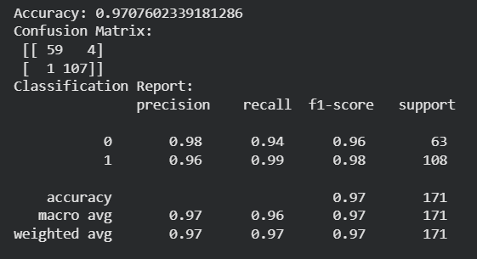
Exp-13
from sklearn.datasets import load_breast_cancer
from sklearn.model_selection import train_test_split
from sklearn.tree import DecisionTreeClassifier
from sklearn.metrics import accuracy_score, confusion_matrix, classification_report
data = load_breast_cancer()
X = data.data
y = data.target
X_train, X_test, y_train, y_test = train_test_split(X, y, test_size=0.3, random_state=42)
model = DecisionTreeClassifier(random_state=42)
model.fit(X_train, y_train)
y_pred = model.predict(X_test)
acc = accuracy_score(y_test, y_pred)
cm = confusion_matrix(y_test, y_pred)
cr = classification_report(y_test, y_pred)
print("Accuracy:", acc)
print("Confusion Matrix:\n", cm)
print("Classification Report:\n", cr)
output:

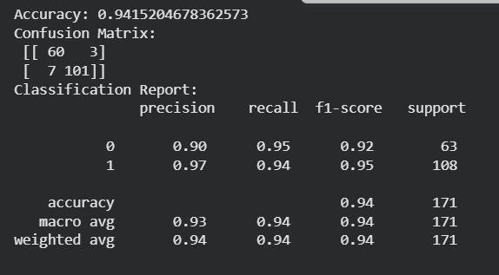
Exp-14
from sklearn.datasets import load_breast_cancer
from sklearn.model_selection import train_test_split
from sklearn.neighbors import KNeighborsClassifier
from sklearn.metrics import accuracy_score, confusion_matrix, classification_report
data = load_breast_cancer()
X = data.data
y = data.target
X_train, X_test, y_train, y_test = train_test_split(X, y, test_size=0.3, random_state=42)
model = KNeighborsClassifier(n_neighbors=5)
model.fit(X_train, y_train)
y_pred = model.predict(X_test)
acc = accuracy_score(y_test, y_pred)
cm = confusion_matrix(y_test, y_pred)
cr = classification_report(y_test, y_pred)
print("Accuracy:", acc)
print("Confusion Matrix:\n", cm)
print("Classification Report:\n", cr)
Output:
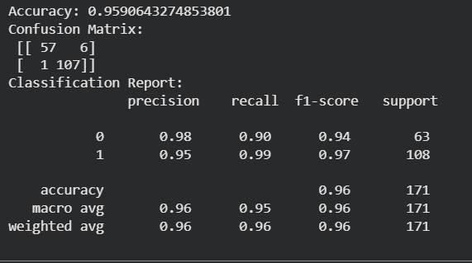
Exp-15
from sklearn.datasets import load_breast_cancer
from sklearn.model_selection import train_test_split
from sklearn.svm import SVC
from sklearn.metrics import accuracy_score, confusion_matrix, classification_report
data = load_breast_cancer()
X = data.data
y = data.target
X_train, X_test, y_train, y_test = train_test_split(X, y, test_size=0.3, random_state=42)
model = SVC(kernel='linear')
model.fit(X_train, y_train)
y_pred = model.predict(X_test)
acc = accuracy_score(y_test, y_pred)
cm = confusion_matrix(y_test, y_pred)
cr = classification_report(y_test, y_pred)
print("Accuracy:", acc)
print("Confusion Matrix:\n", cm)
print("Classification Report:\n", cr)
output:
